DATA VISUALIZATION

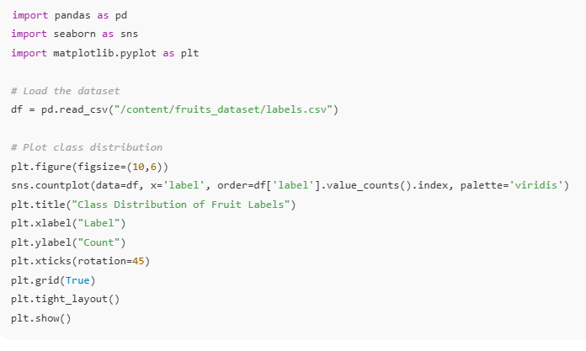 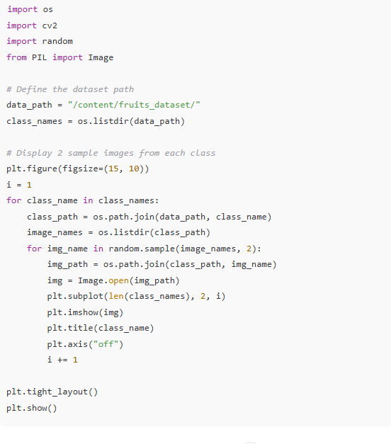

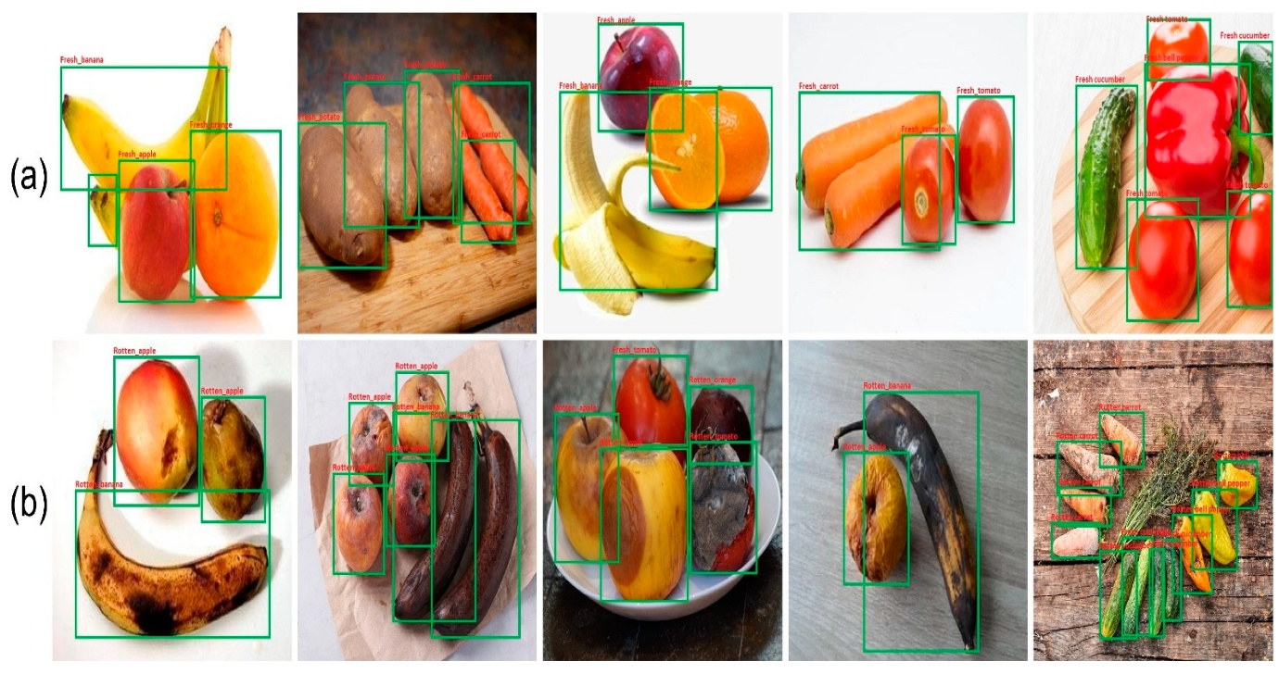

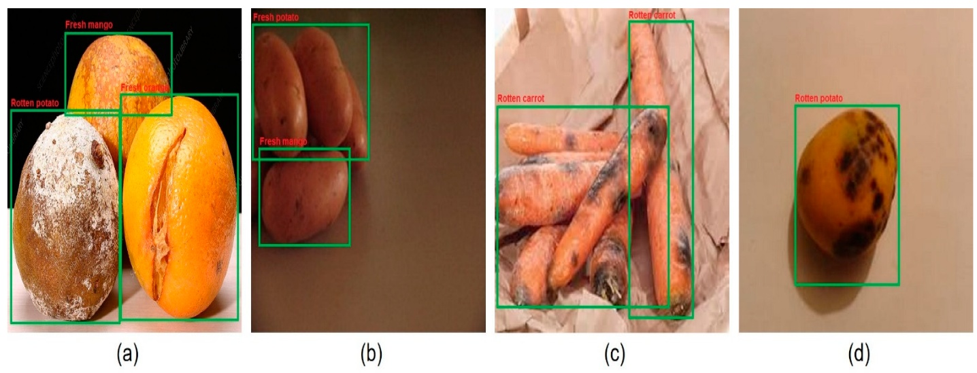

In the above code, I used class ace of diamond for prediction, this code randomly selects an image file from a specified folder (folder path) containing JPEG, PNG, or JPEG files, and then displays the selected image using I Python’s display function. It utilizes Python's OS and random modules for file manipulation and random selection, respectively. And It has predicted correctly as ace of diamond.